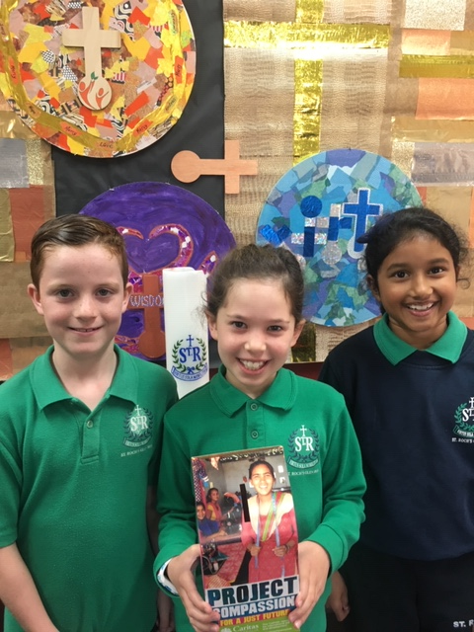**Contents**

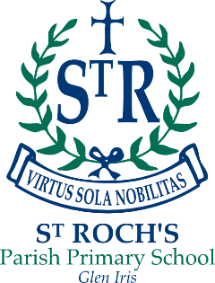

REGISTERED SCHOOL NUMBER: E1128

2018

ANNUAL

REPORT

TO THE SCHOOL

COMMUNITY

ST ROCH’S PARISH PRIMARY SCHOOL

GLEN IRIS

Contact Details 2

Minimum Standards Attestation 2

Our School Vision 3

School Overview 4

Principal’s Report 6

Parish Priest’s Report 9

Parish School Board Report 10

Education in Faith 11

Learning & Teaching 14

Student Wellbeing 21

Child Safe Standards 24

Leadership & Management 26

School Community 29

Future Directions 32

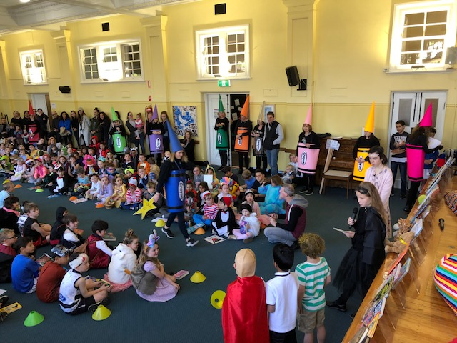

Contact Details

|  |  |
| --- | --- |
| ADDRESS | 3 Glenvale Road Glen Iris VIC 3146 |
| PRINCIPAL | Mr Richard Jacques |
| PARISH PRIEST | Fr Michael Gallacher |
| SCHOOL BOARD CHAIR | Mrs Anna Straford |
| TELEPHONE | (03) 9885 7704 |
| EMAIL | principal@srgleniris.catholic.edu.au |
| WEBSITE | www.srgleniris.catholic.edu.au |
| E NUMBER | 1128 |

Minimum Standards Attestation

|  |
| --- |
| I, Richard Jacques attest that St Roch’s Parish Primary School is compliant with:   * All of the requirements for the minimum standards and other requirements for the registration of schools as specified in the *Education and Training Reform Act 2006 (Vic)* and the *Education and Training Reform Regulations 2017 (Vic)*, except where the school has been granted an exemption from any of these requirements by the VRQA * Australian Government accountability requirements related to the 2018 school year under the *Australian Education Act 2013 (Cth)* and the *Australian Education Regulations 2013 (Cth)*     14 May 2019 |

Our School Vision

***St Roch’s is a nurturing, socially just community.***

***We inspire a passion for learning and excellence and***

***we are a living testament to our Catholic story.***

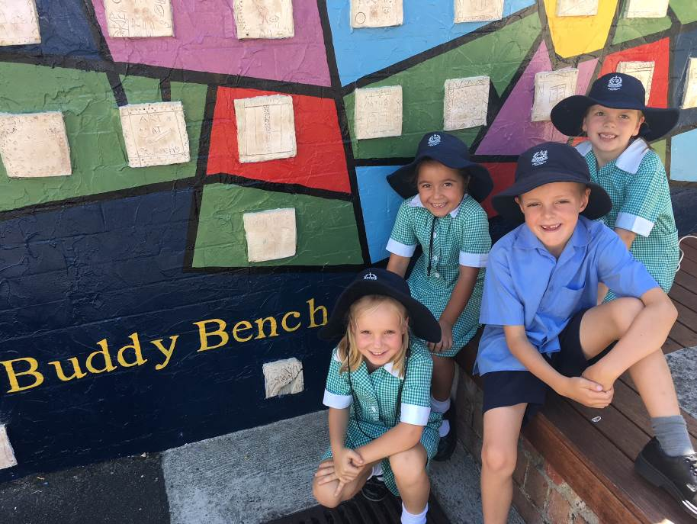School Overview

St Roch’s Parish Primary School is a school with a big heart. St Roch’s has been serving families of the Glen Iris Parish since 1928. We are proud that we are a nurturing and positive school. The emphasis is on creating a welcoming and safe environment, where children are not only cared for, but also encouraged to achieve academic excellence. We aim for all our students, as learners in a Catholic school, to be confident, resilient and discerning well rounded individuals.

*“We endeavour to develop deep learning, powerful teaching and to create animated learners, inspired by the Gospel and led by the Holy Spirit to act with justice and strive for the common good.”*

*Horizons of Hope, Catholic Education Melbourne*

**Community**

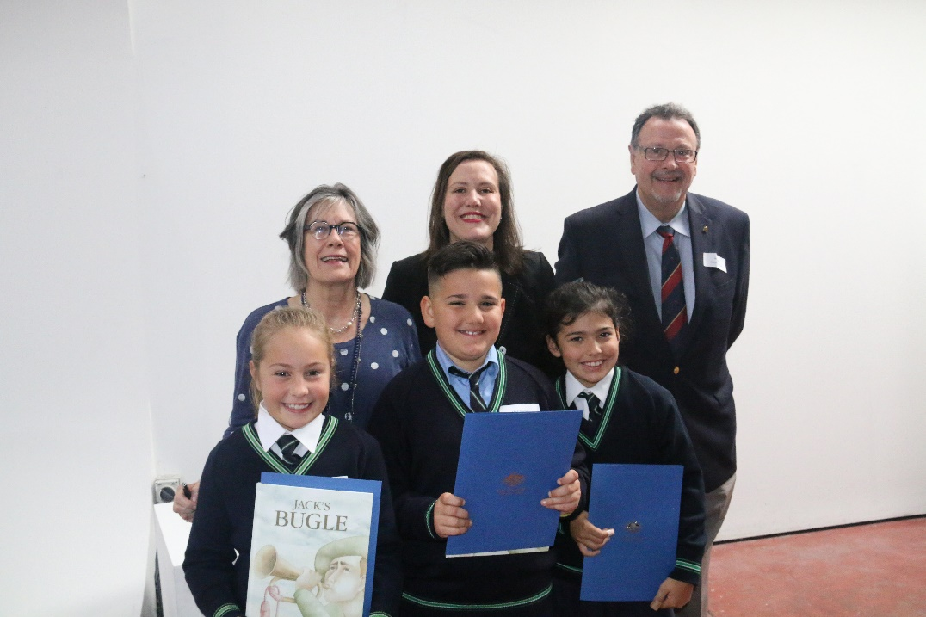The sense of community is strong at St Roch’s. We enrol families, not just students, and we take the time to get to know each and every person in our community. We are proud of our Catholic faith. We live out the wisdom and justice of the Gospel values in all that we say and do. We seek to help the children develop their personal relationship with Jesus Christ.

At St Roch’s we make important connections with the local community, such as local kindergartens, aged-care homes and parishioners. Our staff and students foster sincere relationships within the school and with the wider community. We aim for our students to develop deep understandings of themselves, others and their world.

**Academic Excellence**

**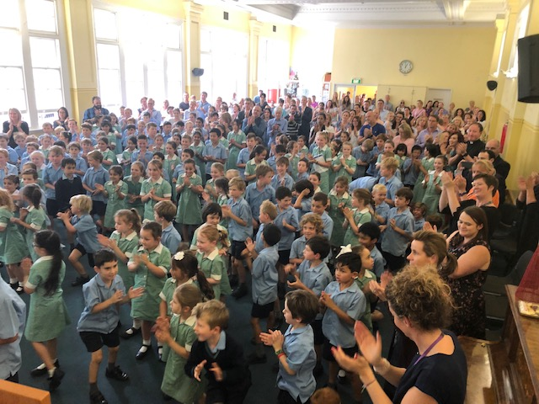**Our benchmarks are set high. We achieve above the national standard level for both literacy and numeracy. Our students are educated and inspired through rigorous, relevant and personalised teaching strategies. Opportunities for enrichment and intervention are offered throughout the school. The specialist lessons at St Roch’s include Performing Arts, Physical Education, Italian and Library.

Additional programs and extracurricular activities offered include: Fountas and Pinnell Levelled Literacy Intervention, an Enrichment Program, bi-annual Art Exhibition/School Production, Interschool Sport in years 4/5/6, Cross Country, Athletics, Sports Day, Swimming Program, Bike Education, Camping Program for Year 5 and 6, ICAS Competitions, Tennis Coaching before and after school, Netball, Lunchtime Dance, Chess, Lego, Tinkering and Library Classes, Coding Club, St Roch’s Orchestra, Music Lessons (voice and instrumental individual and group lessons) and Out of Hours Care Program (OSHC) Program operating from St Roch’s Hall.

Students have access to contemporary learning tools including Chromebooks, laptops, iPads and interactive whiteboards. As an inquiry based school, our students are encouraged to think critically and make authentic connections with their learning. Curiosity and positive mindset are fostered through our inquiry approach and skills in Science, Technology, Engineering and Mathematics are highlighted. We encourage our students to be open minded, creative and reflective with a lifelong love of learning.

**Wellbeing**

At St Roch’s we focus on building relationships and a sense of wellbeing. Each child is known by name. Their passions, skills and interests are acknowledged and fostered. Our staff are highly committed to the education of the whole child; they are dedicated, motivated and caring. Social and emotional skills are explicitly taught in each classroom. With encouragement, pastoral support and buddy programs, our children are inspired to shine.

**Facilities**

Located next to our historic Church, the school is housed in a beautiful, multilevel, air conditioned building comprising of eight classrooms, an Art room, an open learning space, administration and an original hall with period features. We have a wonderful and welcoming library, and enjoy the use of two Parish tennis courts and clubroom. Our students enjoy playing together on the adventure playground, and across all areas of the yard taking particular care to look out for each other.

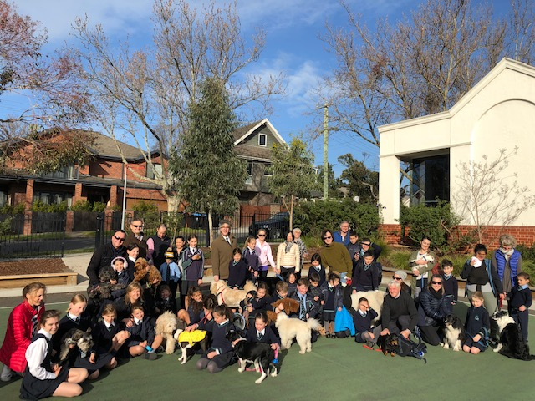

Principal’s Report

2018 has been another successful year for student academic results at St Roch's and this is evidenced by a significant number of students who have achieved in the top two bands as measured by NAPLAN in Numeracy, Reading and Writing.  We are particularly excited about our NAPLAN Writing results as they reflect the continuing Professional Learning that our staff undertake in order to cater for the individual learning needs of our students. Academic Excellence continues to be high on our agenda at St Roch’s and we continue to build on the success of being named in the top 50 primary schools in Victoria in the annual 'Your School Report', published in The Weekend Australian newspaper in October 2016. Your School, a detailed snapshot of the performance in Australian schools, identifies the benchmark as the National Assessment Program - Literacy and Numeracy (NAPLAN) tests in reading, writing, spelling, grammar, punctuation and numeracy for students in Years 3, 5, 7 and 9. Our ranking of 45th was determined by our growth in NAPLAN results from Years 3 to Year 5.

We identify this achievement as evidence of the Literacy and Numeracy initiatives that we have implemented in 2018; particularly the Literacy Coaching, Writing Enrichment Programs and the Mick Ymer Mathematics Project focusing on differentiation and open ended Mathematics tasks. Working as a coach across all P-6 classrooms, the Literacy Leader modelled and observed literacy lessons in classrooms and provided feedback to individual teachers. As a result, the teachers’ capacity to deliver quality literacy teaching and learning continued to grow. A Writing Enrichment teacher was employed for one day a week to support teachers and talented writers in Years 1-6.  Through using the Writers’ Notebook approach to writing, teachers increased their repertoire of instructional strategies and students were given many opportunities to create richer texts for different purposes. These initiatives have built teacher expertise and a shared vision of high expectations for all learners at St Roch’s.

We believe that engaging learning design, through our inquiry model and whole school/community projects, creates the learning environment that supports the full flourishing of all of our students and continues to build a culture for the achievement of above standard NAPLAN results. We are committed to embedding best contemporary practice into the learning community as we encourage students to strive for excellence in all they do. We celebrate this together with all in our community, particularly our parents who are working in partnership with us.

In 2018 we continued our journey as part of a Science, Technology, Engineering and Mathematics (STEM) Collective.  For this Collective we have partnered with St Bridget’s Greythorn, St Dominic’s Camberwell and Holy Saviour Vermont. Our Collective Critical Challenge is to build teacher capacity to teach Science and increase student interest and knowledge in STEM related fields to improve their problem solving, creative thinking and critical analysis skills. This strong partnership and approach to learning has been highly successful and we look forward to sustaining this work in 2019.

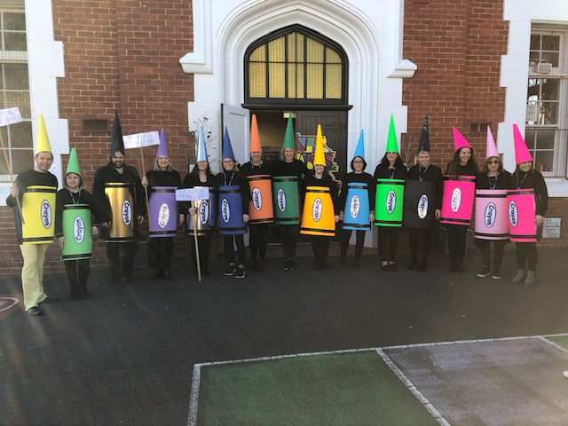

Relationships and the wellbeing of our school community are central to all we do at St Roch’s Parish Primary School. Students have a positive attitude towards school and are highly engaged, confident and motivated learners. We acknowledge the importance of the individual student and our desire to support each child to develop to their full potential. This is reflected in many of the initiatives led by our Wellbeing Leader that have focused on empowering students to develop confidence and resilience. We have provided opportunities for students to take on leadership roles within the school community. The Student Representative Council take a lead in managing the St Roch’s Buddy Bench that all students can visit which helps the students to feel safe and have a stronger sense of belonging.  Leadership programs such as Mini Vinnies have increased student voice and provided an opportunity to develop relationships with each other and with God.

Building on last year’s theme of story (‘My Story, Your Story, Stories of Faith… Our Story with God’) we took on ‘Places’ as our theme for the 2018 school year. While it was a big part of the learning for our students it was also a very special theme for us as a staff.  On Friday 8 June, Fr Gallacher and the St Roch’s Staff met at the Carmelite Monastery in Kew and learnt more about sacred places and we prayed together.  Place is the concept that was taught across the school in 2018. Students learnt about sacred places in their lives and in the Catholic faith. They learnt about how they can take their learning to new places, the significance of places to different people, about our place in the world and in the universe and about the place of people and objects in relation to others within a system.  And, as Catholics, we continued to take our faith to new places.

### C:\Users\office\AppData\Local\Microsoft\Windows\INetCache\Content.Outlook\HU1E7F2I\IMG_5292.JPG

### We partnered with our parents and members of the community to present our biennial St Roch’s Art Exhibition. We were so proud of each and every student involved.  It was our pleasure to showcase a collection of the students’ magnificent artwork which they carefully and proudly created. In curating this event, we were inspired by our school theme “Go to new places”. Art has the power to take us to many new places. As everyone walked through the Art Exhibition we took them on a journey where they learnt about the significance of locations to different people, about our place in the world and about sacred spaces that are important to our faith. In the movie, ‘The Greatest Showman’, Lettie sings, “I know that there’s a place for us…” In our school and in our Art Exhibition we know there was a place for every student to shine.

### C:\Users\office\AppData\Local\Microsoft\Windows\INetCache\Content.Outlook\HU1E7F2I\IMG_1185.jpgAt St Roch’s we encourage students to develop a growth mindset. Persistence and resilience are important skills for young artists as they trial new techniques and media and communicate their ideas. Throughout the year, the students were inspired by a number of other artists such as author Felice Arena, illustrator Heath McKenzie and film director Michael Gracey who taught them about the importance of believing in yourself and never giving up. Our exploration of the concept of place has occurred in both English and Italian and involved students learning about gardens, geology, the Earth and shadows, natural resources, migration, and using their imagination to think about future places. This learning has been deepened by connections with Scienceworks and the National Gallery of Victoria and supported by our collaboration with three other Catholic primary schools in a STEM and Languages collective facilitated and funded by Catholic Education Melbourne. We believe the Art Exhibition was a celebration of all this important learning. Art is important for many reasons. It is an effective medium for developing critical and creative thinking skills. Students learnt how to express their ideas in unique and novel ways and how to consider how other artists perceive the world around them. At times, creating artworks also requires students to collaborate with others to achieve a common goal. It involves students in making decisions and thinking about the most powerful ways to communicate and connect with their audience. These are all important life skills that will stand students in good stead for the future. All of this would not have been possible without an amazing community behind us - a community where each person is valued and cared for and where the highest standards are upheld. Thank you to our parents for partnering with us.

**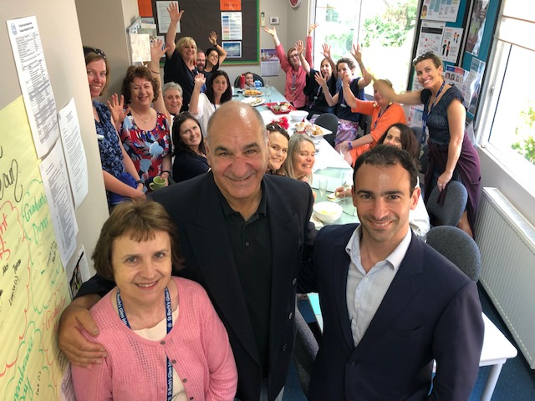**Anna Jabour retired at the end of the 2018 school year after 29 amazing years of service.  We are very grateful for Anna’s dedication and love of the students at St Roch’s. I would like to honour and acknowledge Anna for the work, collegiality and care that she have shown to the students, their families and all of us on staff.

The St Roch’s community is proud of its school, and leaders and staff strive to develop a culture of being open minded and open hearted whilst improving outcomes for all students. We are committed to embedding ‘best’ teaching practice as we encourage students to strive for excellence in all they do.  I take this opportunity to thank our Parish Priest Fr Michael Gallacher, Deputy Principal, Angelina Mastoras, the Leadership Team, Staff, Parish School Board, the Parents and Friends Association and the entire   
St Roch’s community for their commitment and energy in helping make St Roch’s to be the great school it is today.

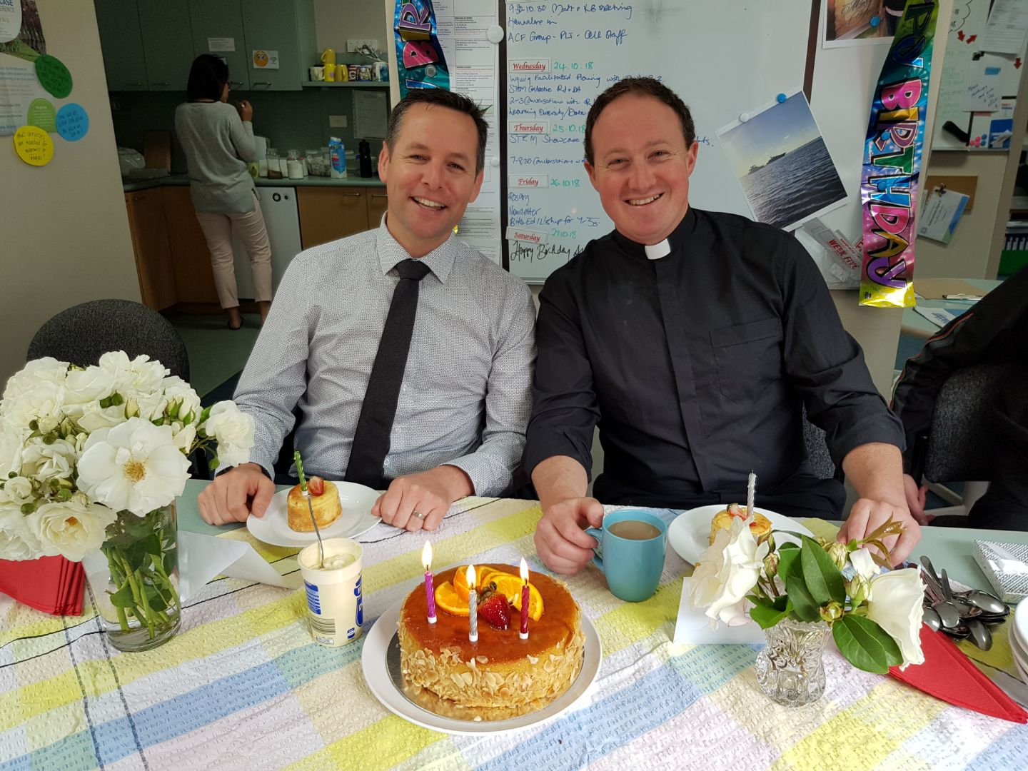Our school continues to grow and we are proud to have over 170 students from 125 families making up our community.

**Richard Jacques**

**Principal**

Parish Priest’s Report

This year at St Roch’s Parish School was another wonderful and busy year. I appreciated the opportunity to visit classes, celebrate whole school Masses twice a term and a Sunday family Mass for each year level. It was wonderful to have an increasing number of parents join us for the special Masses during the term in particular.

On St Patrick’s Day I joined our Year 6s at the cathedral for Mass with Archbishop Hart, which we followed with a tour of the cathedral. On Ash Wednesday we celebrated a liturgy of the Ashes in our parish church.

The children spent many weeks preparing the annual Holy Week re-enactment. This year the 2/3s added a scene from the Garden of Gethsemane, which they re-enacted in the presbytery garden. This added to the prayerfulness of the whole event. It was a beautiful way for our children, parents and staff to prepare for the celebration of the Easter Ceremonies.

Early in the year we prepared our children for and celebrated their First Reconciliation. Later in the year we prepared our children to receive their First Holy Communion. This included a retreat day in which the children engaged deeply. At the celebration of First Communion itself the children were reverent and prayerful, a wonderful example to the rest of us of the mystery of the Eucharist.

In 2018 we also had the celebration of Confirmation for our 5/6s. These children were thoroughly prepared by their teachers, and enjoyed a retreat day with the other children from the parish preparing for Confirmation from outside our school. We also spent some time together in preparation during the 5/6 camp at Grantville. The evening with Monsignor Ireland was a joyful and uplifting occasion, and we were proud of our students taking this step forward in their faith.

On All Souls Day we celebrated a Mass at lunchtime which was optional for the children, and a significant number of our children chose to attend. They had the opportunity to write the name of deceased loved ones from their families, or the families of their friends, and place these before the altar during Mass.

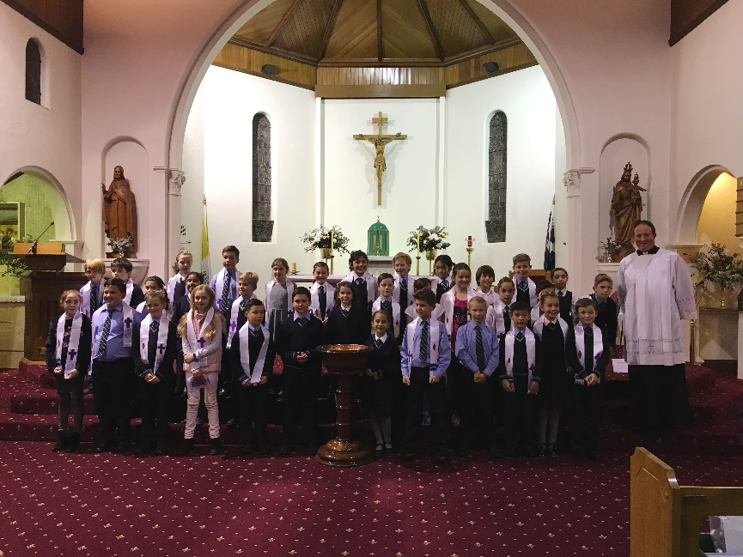

The St Roch’s Parish School Board was a wonderful support to the Parish Priest and the Principal. Our school principal and deputy, Mr Richard Jacques, and Mrs Angelina Mastoras, were a delight to work with. I continued to be inspired by their genuine love and concern for our students. Mr Jacques and I attended several briefings regarding the government funding situation of Catholic schools. The relationship between the Parish Priest and school leadership is a key relationship in any parish, and I am grateful for the strength of that relationship that deepened throughout 2018.

I am sure that all our activities as a parish school in 2018 brought us closer to Christ, and I look forward to more of the same in the future!

**Father Michael Gallacher  
Parish Priest**

Parish School Board Report

The purpose of the Parish School Board is as an advisory body to the Parish Priest of St Roch's Parish, the Principal and to the staff of the school in all matters relating to the school’s directions, goals, programs and policies. The Board advises, in a spirit of cooperation, with the Parish Priest and Principal regarding the operation of the school.  The Board meetings have provided a forum for discussion of new policies, strategic planning other initiatives considered for the school. Being a member of the Parish School Board gives the members insight into the strategic planning and global operations of the school such as policy development, budget planning, and funding programs as well as hearing an overview of the myriad of activities that take place within the school over the course of the school year.  In 2018, St Roch’s has continued to live out its school vision in all of its facets. St Roch’s should be rightly proud of its excellent academic results as evidenced by the continual monitoring of data and trends in growth, its caring environment and the welcoming community created by the staff and families.

Our Board meetings each term allow us to follow the trajectory of the school year as it unfolds and over the years during my time on the Board, it has been evident that St Roch’s is an exciting and stimulating and very busy small school! The work of the Board while is largely to act as a sounding board and in an advisory capacity to Fr Gallacher, it does give us an insight into the range of ways each staff member contributes to the mosaic which is the school year in entirety. The Principal’s report presented at each meeting have allowed each of the members to gain an appreciation of the attentive, meticulous planning of the school staff to provide the students with a deep faith, and love of learning, in a community of acceptance.

It is astounding to note just how much is done in the course of a term across the seven year levels, in all facets of curriculum: literacy and numeracy, Religious Education, ICT, Music and Performance, Creative Arts, Inquiry Based learning, Italian, Library and Physical Education. To deliver such programs properly, requires a team effort that includes not only the teaching staff and the Learning Support Officers, but also the Office administration staff. The Board acknowledges too, the complexity of the mechanics of operating a school like St Roch’s and the increasing need for more funding. I am deeply appreciative to both Fr Gallacher and Richard Jacques for their commitment towards voicing the concerns of many staff and parents about the school funding model proposals. Their willingness to spend time writing letters, making phone calls, attending meetings and petitioning on the behalf of the school community has been exemplary and generous to a fault.

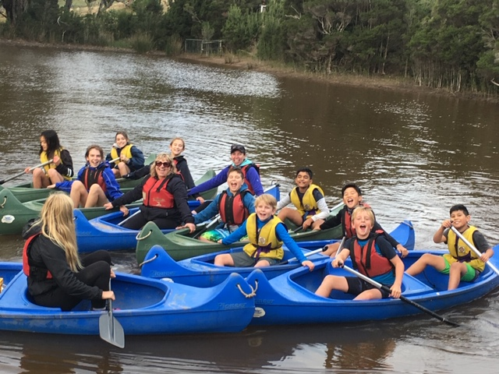It is essential to gratefully acknowledge the high degree of professionalism shown by all staff throughout 2018.  Their care and genuine love and concern for the students has meant that each child feels a strong connection to their school and in turn then they strive and thrive. On behalf of the members of the parish school board I would like to extend our deepest gratitude and appreciation to all staff for their hard work and creativity, and ongoing contribution, that has ensured that St Roch’s school continues to be a nurturing faith community committed to encouraging its students to be open minded and openhearted.

**Anna Straford**

**Chairperson**

**St Roch’s Parish School Board**

Education in Faith

## Goal

To shape and nurture authentic connections between our Catholic faith and life.

## Intended Outcome

That students and staff will engage in critical dialogue connecting the Catholic tradition and life.

Hh

## Achievements

**The school celebrated the following successes in 2018 in Education and Faith:**

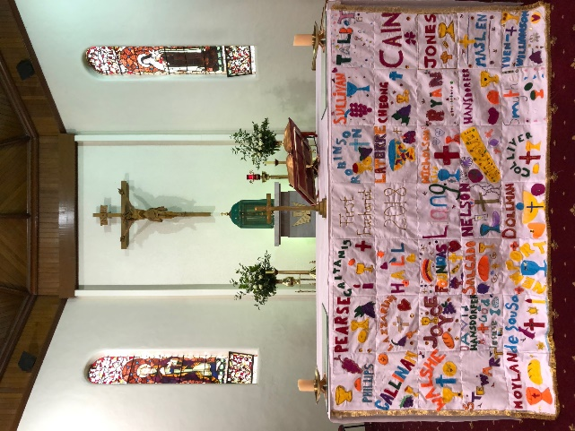

* An active partnership between staff, students, parents and the wider parish community with our Parish Priest, Fr Gallacher leading school and parish liturgical celebrations.
* Fr Gallacher joined students and staff on Fridays in 2018 including weekly meetings with both the Principal and Deputy Principal/Religious Education Leader
* Staff Formation Day at the Carmelite Monastery where the staff prayed, learnt about the Carmelites and joined in Mass celebrated by Fr Gallacher. Our Parish Priest and Religious Education Leader (REL) organised opportunities for staff to reflect on their own life and faith and make connections with Catholic traditions and sacred places.
* Families took up the invitation to attend Mass on a given Sunday with their year level and to stay afterwards for morning tea or wine and cheese, dependent on the Mass time selected enabling a closer Parish/School partnership.
* The 2018 Sacrament Program included Reconciliation, First Holy Communion and Confirmation. Family nights, Parish Commitment Masses and retreat days were led by Father Gallacher, the REL and staff.
* A structured professional learning cycle was used for Religious Education planning with close links being made with the Inquiry Process in Learning and Teaching. Catholic Tradition, the Liturgical Seasons and Doctrine underpin the content of the units being taught. The Religious Education Curriculum Framework and To Know Worship and Love Texts are our main resources.
* A consistent approach to planning that considers student interests and incorporates greater student voice and choice in demonstrating their learning was achieved across all levels of the school.
* The Religious Education Team continued to participate in the RE Collective. This included collaborating with another school to discuss, share and reflect on Religious Education processes within our schools.
* We focused on building the knowledge and capacity of staff to understand the three strands within the Religious Education Framework; Knowledge and Understanding, Reasoning and Responding and Personal and Communal Engagement. Understanding the standards and assessment practices that show evidence of learning was also a focus.
* Data from a Religious Education Staff Survey indicated that the RE Collective would focus on:

1. Assessing to understand the progression of every learner and their learning journey - asking the question: What are we assessing and how do we best establish where learners are in their learning?

2. Leading Unit design for deep and authentic learning in our Catholic School - asking the question: What are we designing for and how do we best collaborate to enable this?

* 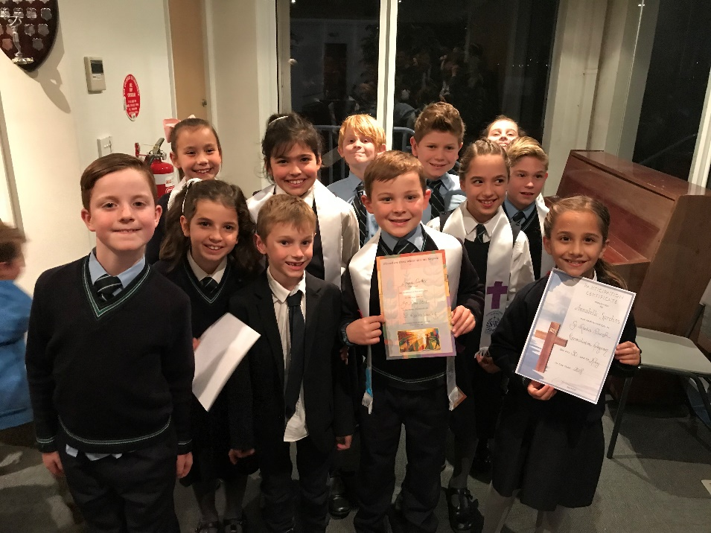Through Learning Conversations with students we refined our Inquiry into Religious Education by asking the question: How do we design for assessment that enables deep learning and growth in Religious Education for all students? This question led our Professional Learning Team meetings and Facilitated Planning.
* An audit of our units of work is conducted each term based on the three areas of the learning descriptors, Knowledge and Understanding, Reasoning and Responding and Personal and Communal Engagement.
* Professional Learning Team meetings and facilitated planning sessions throughout the year focused the planning pre, during and post assessments that provided evidence of students’ learning.
* The REL worked with teachers in integrating Religious Education, our Catholic story, faith and traditions into other curriculum areas.
* Through celebrating our diversity and linking our curriculum with Global Perspectives and Values Education, we have demonstrated a strong commitment to social justice and action in the school and wider community supporting organisations such as CatholicCare, St Vincent de Paul and Caritas.
* The St Roch’s Art Exhibition, held in Term 3, included artwork based on sacred places that students visit with their families.

|  |
| --- |
| VALUE ADDED |
| * Ash Wednesday Liturgy and distribution of Ashes celebrated with parishioners and parents * Parish Adult Faith Nights with the Honourable Tim Fischer MP and the Honourable Christine Campbell MP * Year 5/6 joined Fr Gallacher at the Catholic Education Week/St Patrick’s Day Mass at the Cathedral and toured the cathedral * A reverent and prayerful Holy Week Re-enactment and Easter Celebration attended by families and led by Fr Gallacher * Angie Mastoras (REL) is on the RE Executive for CEM Eastern Region and was successful in receiving CEM RE Grant for RE Collective with Sacred Heart Primary School Croydon * Preps in Pyjamas Prayer Night * Whole School Masses, for example, Beginning and End of Year, Sacred Heart of Jesus Poor Man’s Mass and the Assumption of the Blessed Virgin Mary * Students donated cereals, toiletries, pasta and non-perishable items to the St Vincent de Paul Appeal * St Roch’s Feast Day celebrations * Year 5/6 students welcomed Ashwood Cabrini Residents to St Roch’s to share stories and work on group art piece * The Rosary was prayed throughout the month of October for Prep to Year 6, staff and parents * All Souls Day Mass offered at lunchtime for school children, staff and parents * Altar Serving Training offered to parish students who have received First Holy Communion * The Prep students brought the Nativity to life and Christmas Carols remained a favourite night for our community * End of Year Mass and passing on the light from 2018 Year 6s to 2019 Year 6s |

From Insight SRC Annual Survey Data - Evidence of effectiveness

The Catholic Culture Aggregate Index data from the annual parent, staff and student surveys indicates that St Roch’s is well above the Australian mean with an upward trend from 2016 in both staff and student data. Examples of this satisfaction are clearly indicated by the following results:

**Students:** **Scores on a scale of 1-5, with 1 being the lowest score and 5 the highest score.**

* At this school I have the opportunity to learn about the Catholic faith – 4.3
* At this school I have the opportunity to celebrate Mass – 4.4
* At this school I have the opportunity to participate in prayer – 4.5
* At this school I have the opportunity to reflect on my faith – 4.3
* At this school I am encouraged to be compassionate – 4.4

**Staff:** **Scores on a scale of 1-5, with 1 being the lowest score and 5 being the highest score.**

* Teaching at a Catholic school is very important to me – 4.5
* At this school I have the opportunity to learn about the Catholic faith – 4.5
* At this school I have the opportunity to celebrate Mass – 4.7
* At this school I have the opportunity to participate in prayer – 4.7
* At this school I am encouraged to be compassionate – 4.6

**Parents**: **Scores on a scale of 1-5, with 1 being the lowest score and 5 being the highest score.**

* My child attending a Catholic school is very important to me – 4.0
* The school provides the opportunity for my child to learn about the Catholic faith – 4.7
* The school provides the opportunity for my child to celebrate Mass – 4.6
* The school provides the opportunity for my child to participate in prayer – 4.5
* At this school my child is encouraged to be compassionate – 4.5
* 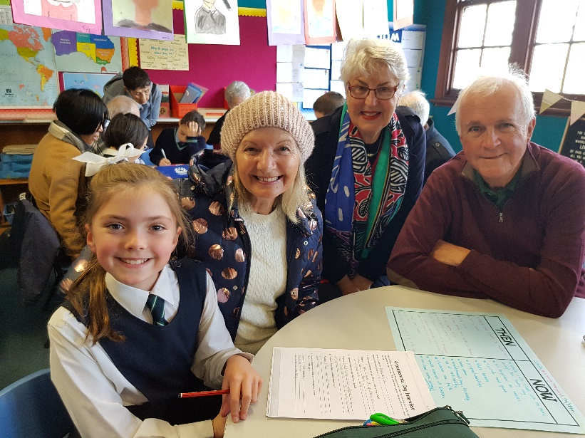This school raises my child’s awareness of social justice issues – 4.1

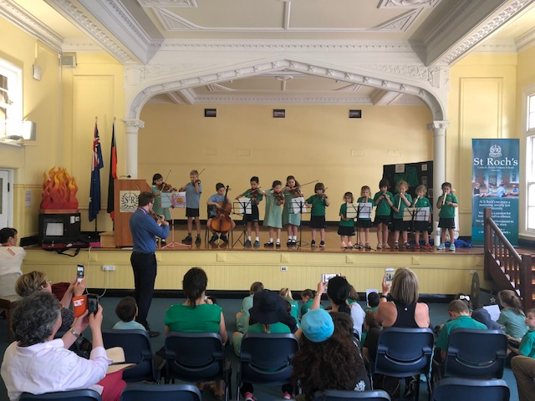

Learning & Teaching

## Goal

To personalise learning to ensure that students are supported and challenged to maximise their potential.

## Intended Outcomes

* That student engagement is improved.
* That student growth in Literacy improves.
* That student growth in Numeracy improves.

## Achievements

**The school celebrated the following successes in 2018 in Learning and Teaching:**

* A structured planning cycle continued to be used for Integrated Inquiry planning. The first stage of the cycle begins with a provocation, some professional learning about the curriculum area and the development of a P-6 Learning and Teaching Statement which integrates conceptual understandings, student skills and consideration of the Catholic context around the learning. The second stage is a full day of planning for teachers P-6 and stage three is a two-hour facilitated planning session early in the teaching of the inquiry for teachers in each year level.
* Each stage of the planning cycle provided opportunities for teachers to increase their content knowledge of the Victorian Curriculum.
* Professional Learning Team meetings and facilitated planning sessions throughout the year focused on student engagement in Integrated Inquiry planning.  Students’ prior knowledge and interests were identified early in the unit and informed planning for the remainder of the term.
* A consistent approach to planning that considers student interests and incorporates greater student choice in demonstrating their learning was achieved across all levels of the school.
* The two-year cycle for Integrated Inquiry units was evaluated at the end of 2017. A new two-year cycle was developed for 2018-2019 including a focus on Civics and Citizenship and Aboriginal and Torres Strait Islander histories and cultures.
* Teachers continued to participate in the Eastern Region Science, Technology, Engineering and Mathematics (STEM) Collective. This involved staff in professional learning about the STEM approach with staff from three other schools. This led to a better shared understanding of STEM and increased capacity of all teachers in planning for effective integration of a STEM approach and the development of a bank of resources and ideas for all four schools to use.
* Two professional learning days for the four schools in the STEM Collective were held at Scienceworks in Term 1 and the National Gallery of Victoria in Term 3. These days provided a springboard for the development of inquiry learning units from P-6.
* PAT- Science data was collected from Years 1-6 to measure impact of STEM on learning in Science.
* The St Roch’s Art Exhibition, held in Term 3*,* was a culmination of the students’ learning and combined the students’ knowledge and beliefs learned through inquiry with their knowledge and skills in Visual Art.
* Leaders from St Roch’s showcased the school model of Integrated Inquiry planning with a number of other school groups at the Eastern Region Learning Fair held in Term 4.
* Students from Years 2 and 3 participated in the STEM MAD Showcase hosted by Catholic Education Melbourne and received the CERES Award for Best Innovation for Sustainability.
* A program in developing students’ reasoning skills through Philosophy was trialled with students in 3/4K. Lessons and resources have been provided to the rest of the staff for their professional learning. The feedback from both staff and students was that the trial was engaging for all students and that the students have a better understanding of good reasoning and their reasoning skills were enhanced by the opportunity.
* Students in Years 5/6 participated in the Tournament of Minds for the first time in 2018. This Tournament is held annually and is an opportunity for students with a passion for learning and problem-solving to demonstrate their skills and talents in a new and public way. All students in Years 5/6 practised spontaneous challenges designed to develop critical and creative thinking, problem-solving skills and collaboration skills. A team of 7 students then went on to develop their skills in the longer-term challenges. This team participated in the Tournament of Minds and represented St Roch’s very well, receiving an Honours award for their presentation.

**The school celebrated the following successes in 2018 in Learning Diversity:**

* Students identified on the NCCD Data were monitored by all leaders. The Learning Diversity Leader coordinated Interventions in conjunction with the Learning and Teaching, Literacy and Mathematics Leaders and Learning Diversity Team.
* Differentiation of learning for students with Personalised Learning Plans (PLP) Adjustments occured at Learning Diversity Facilitated Planning and Learning Diversity PLTs with the Learning Diversity Team ensured that programs and interventions catered for the individual needs of the students.
* Personalised Learning Plans are evaluated and shared with parents at Program Support Group (PSG) meetings once per term.

**The school celebrated the following successes in 2018 in the Learning and Teaching of English:**

* A structured iteration approach continued to be used in Professional Learning Teams (PLT) meetings to build teacher knowledge of language and of the English curriculum and to support a robust model of teaching and learning informed by data.
* Time was allocated at the beginning and end of the year to individual teachers to collect and analyse data in reading and writing across the school. This data together with ongoing data collection and teacher judgement was used in facilitated planning time to plan for focused and differentiated teaching.
* A review of the English Assessment Schedule enabled reflection and improvement in developing a purposeful approach to whole school assessment.
* A school-based Assessment website was launched as an online platform to store all formal English assessment data across the school. This allows easier teacher access to information for planning and allows monitoring of student progress by school leaders.
* Two classroom teachers along with the Literacy Leader participated in the Phonics in Context Research Project organised by the Catholic Education Melbourne (CEM) in collaboration with Monash University. As part of this project, short learning sprints were undertaken in two classrooms focusing on identified needs of small groups of students. The teachers involved reported increased professional knowledge and greater success in engaging students in targeted learning in English as a result of planning and implementing these learning sprints.
* Teachers continued to deepen their understanding of the St Roch’s Guiding Principles for Effective Literacy Practice by participating in a Literacy Walk with the Literacy Leader through all the classrooms focusing on the teaching of writing. Time was given to reflecting on observations made in P-6 classrooms and feedback about personal learnings was shared with all staff.
* A Writing Enrichment teacher was employed for one day a week to support teachers and talented writers in Years 1-6.  Through using the Writers’ Notebook approach to writing, teachers increased their repertoire of instructional strategies and students were given many opportunities to create richer texts for different purposes. Opportunities were also provided for Yr 5/6 students to participate in debating, leadership speeches, and for selected students to enter a Poetry Writing competition.
* All teachers undertook professional learning with Lyn Anderson, an international education consultant, around the morphology of the English language. This resulted in increased teacher content knowledge of the English curriculum and a broader repertoire of pedagogical practices which encourage students to inquire into the spelling of English words.
* Working as a coach across all P-6 classrooms, the Literacy Leader modelled and observed literacy lessons in classrooms and provided feedback to individual teachers. As a result, the teachers’ capacity to deliver quality literacy teaching and learning continued to grow.
* Students who had shown particular strength in the area of Writing were given the opportunity to take part in the International Competitions and Assessments for Schools (ICAS) program. This independent, skills-based assessment program organised by the University of NSW recognises and rewards student achievement.
* Parents were trained as Classroom Helpers to enable them to support student learning within the daily Literacy Block in all classrooms.

**The school celebrated the following successes in 2018 in Learning and Teaching of Mathematics:**

* Regular PLTs and Facilitated Planning have developed teachers’ confidence and knowledge of the Mathematics curriculum with a focus on extension and intervention.
* A Mathematics Intervention Program commenced for selected students in Years 1 and 2 with the aim of extending this to Years 3 and 4 in 2019.
* A structured iteration approach to supporting staff where student assessment leads to professional learning in Professional Learning Teams (PLTs) and targeted teaching during Facilitated Planning. Staff reported feeling supported in their planning for differentiation in their classrooms with the increased use of data to drive targeted teaching and leader support.
* Professional development was provided to Years 3-6 teachers to build teacher knowledge of the mathematical concepts of algebra, geometry, multiplicative thinking and statistics and probability. Time was allocated to analysing PAT-M data for strengths and challenges across the school.
* PLTs gave opportunities for staff to partake in professional dialogue and collegial planning to work on improving student outcomes. As a staff, we deepened our use of a range of data to inform student needs. Additional time was allocated for staff to build their understanding of how to analyse Progressive Achievement Tests (PAT) data which enhanced the targeted teaching for students.
* An evaluation of the Mathematics Assessment Schedule enabled reflection and improvement in the approach to whole school planning and assessment and led to the development of an Assessment Plan to define the purpose of assessments used.
* The development of an Assessment site using Google Sites streamlined the location of assessment data.
* The partnership with Catholic Education Melbourne Mathematics Personnel continued to support the School Mathematics Leader.
* Parents were invited to attend a Classroom Helpers training session and encouraged to help in Mathematics lessons.
* Staff continued to improve their practice in the teaching and learning of Mathematics through Professional Learning Team meetings and the continued support of Mathematics Consultant Michael Ymer. Throughout the year the P-6 staff observed in class modelling and time was set aside to reflection to drive where to next.
* Students who had shown particular strength in the area of Mathematics were given the opportunity to take part in the International Competitions and Assessments for Schools (ICAS) program. This independent, skills-based assessment program recognises and rewards student achievement.

|  |
| --- |
| VALUE ADDED |
| * Staff reading Carol Dweck’s Mindset which is a great connection to our Inquiry unit focusing on Healthy Brains and Healthy Bodies * Ongoing Professional Learning with Education Technology Consultant, Marty McGauran, leading staff and students in the effective use of technology at St Roch’s. * 5 staff attended Teach Tech Play two day conference in the holidays * Yr 3-6 Swimming Trials, training and District Swimming Championships with one swimmer going through to Regional Swimming Championships * Introduction of new Coding Club after school * Year 5/6 Camp was a wonderful opportunity for all children to learn to work as a team, take risks and learn new skills * Year 5/6 students attended the ANZAC Day Legacy’s 87th Commemoration Service at the Shrine of Remembrance * House Team Cross Country held at Central Park * Prep visited the Royal Botanic Gardens to inquire into Food Forest and Sustainable gardening * City of Stonnington partnering with Prep to develop Veggie Patch * St Roch’s represented at District Cross Country * Year 3/4 visited the Planetarium at Scienceworks * Year 1/2 Excursion to Gardiner Creek to experience City of Stonnington Wetlands Tour and Indigenous Education * Publishing Parties held for parents and families in Year 2/3 and 3/4 * High Voltage Rock School Concert held in the Hall to celebrate student’s learning * Whole School author visit from Deborah Abela and illustrator Heath McKenzie * Artist in Residence Anne Pullen supported staff with Art lessons in preparation for the ST Roch’s Art Exhibition * St Roch’s House Team Athletics Trials were held at Central Park * Years 3-6 St Roch’s House Athletic Trials * St Roch’s Team competed at the District Athletics for the Balwyn District * Year 5/6 attended Basketball (Hoop Time) for the Balwyn District * Year 5/6 Bike Education Program culminated in the ‘Big Bike Ride’ * Year 5 participated in the Michael Grose Leadership Program * Year 3/4 Incursion with Mr Bunsen – Science/Systems * Year 1/2 Incursion with Supreme Incursions - Science/Systems * Preps attended excursion to LegoLand – Science |

### C:\Users\office\AppData\Local\Microsoft\Windows\INetCache\Content.Outlook\HU1E7F2I\IMG_5969.JPG

**Making A Difference**

**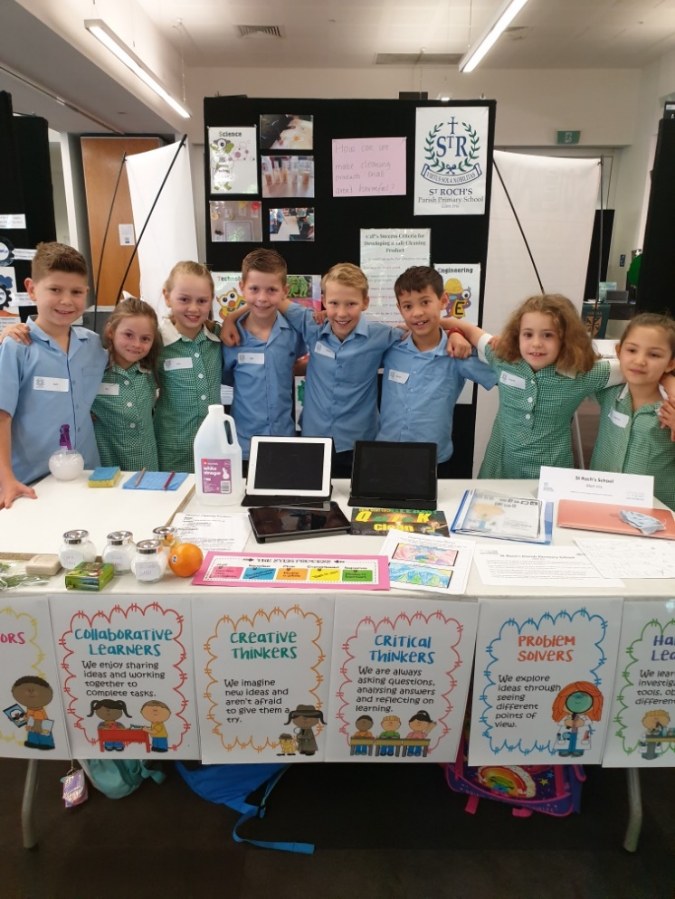**In response to a story about a child whose asthma was exacerbated by chemicals in the cleaning products that were used in his home, the students in Year 1/2 at St Roch’s conducted an Inquiry around the question ‘How can we make cleaning products that aren’t harmful?’ They designed success criteria for their product: it had to be non-toxic, be able to clean texta off a table without leaving residue and to have a pleasing scent. They researched the toxicity of the ingredients in household cleaning products as well as non-toxic alternatives and, in groups, conducted experiments with different ratios of their selected, non-toxic ingredients. Their products were tested against the class criteria and redesigned if they were not successful. The best product was packaged by the students, including a list of the non-toxic ingredients, and given to families and other members of the school community. We believe this cleaning solution will make a difference in our world. At the CEM MAD Showcase Day the team had the opportunity to present their learning journey to other schools and professionals who work in the STEM field. The children got to see what other schools were presenting and listened to

guest speakers. Our team did us proud by winning the ‘Best

Innovation for Sustainability’.

STUDENT LEARNING OUTCOMES

**2018 NAPLAN Data**

|  |  |  |  |  |  |  |  |  |  |  |  |  |  |  |  |  |  |  |  |  |  |  |  |  |  |  |  |  |  |  |  |  |  |  |  |  |  |  |  |  |  |  |  |  |  |  |  |  |  |  |  |  |  |  |  |  |  |  |  |  |  |  |  |  |  |  |  |  |  |  |  |  |  |  |  |  |  |  |  |  |  |  |
| --- | --- | --- | --- | --- | --- | --- | --- | --- | --- | --- | --- | --- | --- | --- | --- | --- | --- | --- | --- | --- | --- | --- | --- | --- | --- | --- | --- | --- | --- | --- | --- | --- | --- | --- | --- | --- | --- | --- | --- | --- | --- | --- | --- | --- | --- | --- | --- | --- | --- | --- | --- | --- | --- | --- | --- | --- | --- | --- | --- | --- | --- | --- | --- | --- | --- | --- | --- | --- | --- | --- | --- | --- | --- | --- | --- | --- | --- | --- | --- | --- | --- | --- |
| |  |  |  |  |  |  | | --- | --- | --- | --- | --- | --- | | **PROPORTION OF STUDENTS MEETING THE MININUM STANDARDS** | | | | | | | **NAPLAN TESTS** | **2016   %** | **2017   %** | **2016 - 2017 Changes  %** | **2018   %** | **2017 - 2018 Changes  %** | | YR 03 Grammar & Punctuation | 95.8 | 100.0 | 4.2 | 100.0 | 0.0 | | YR 03 Numeracy | 100.0 | 100.0 | 0.0 | 100.0 | 0.0 | | YR 03 Reading | 100.0 | 100.0 | 0.0 | 100.0 | 0.0 | | YR 03 Spelling | 95.8 | 100.0 | 4.2 | 100.0 | 0.0 | | YR 03 Writing | 100.0 | 100.0 | 0.0 | 100.0 | 0.0 | |  | | | | | | | YR 05 Grammar & Punctuation | 100.0 | 100.0 | 0.0 | 100.0 | 0.0 | | YR 05 Numeracy | 100.0 | 100.0 | 0.0 | 100.0 | 0.0 | | YR 05 Reading | 100.0 | 100.0 | 0.0 | 100.0 | 0.0 | | YR 05 Spelling | 100.0 | 100.0 | 0.0 | 100.0 | 0.0 | | YR 05 Writing | 100.0 | 100.0 | 0.0 | 100.0 | 0.0 | | | | |  |
|  | ..\bl.jpg |  | ..\bl.jpg | | |  |

**Year 3 NAPLAN**

The above graphs highlight the results based on the minimum standard in NAPLAN from 2016 to 2018. Our results for 2017 indicate that 100% of students across the five disciplines assessed in the NAPLAN tests have reached the minimum standard.

**Year 5 NAPLAN**

The Year 5 NAPLAN results indicate that 100% of St Roch’s students have reached the minimum standard across the five disciplines assessed in 2018. St Roch’s students have continued to perform well in the Australia wide NAPLAN tests across the areas of Reading, Writing, Spelling, Grammar and Punctuation and Numeracy in 2018.

While in all areas our students are above the minimum standards we are actually performing at a very high level in comparison to other schools as indicated by the table below. In the areas of Reading, Writing and Numeracy we have a high percentage of students performing in the top two bands which is well above the expected standard for Year 3 and Year 5.

School Data Set for 2018

|  |  |  |  |
| --- | --- | --- | --- |
| St Roch’s Year 3 2018 | Reading | Writing | Numeracy |
| Top 2 Bands | 75% | 79% | 60% |
| Bottom 2 Bands | 7% | 0% | 4% |
| St Roch’s Year 5 2018 |  |  |  |
| Top 2 Bands | 54% | 36% | 36% |
| Bottom 2 Bands | 0% | 0% | 0% |

The excellent results in Writing in particular is evidence of the strategic approach we have put into place to support the development of writing skills across the school, and the Writing Enrichment Program we have implemented to explicitly teach children at their point of need. Our results in Year 3 Numeracy are also noteworthy and support the approach we have taken to the implementation of pre and post assessment prior to teaching a unit of Mathematics, and the Professional learning for staff to build their expertise in the teaching of Mathematics in the classroom.

One of the areas we have placed emphasis on over the past year is the support of a Literacy Coach in the classroom working alongside teachers, modelling, mentoring and then working collaboratively in planning with staff, to provide teaching and learning in Reading and Writing that is at students’ point of learning need. Our results in Reading and Writing in both Years 3 and 5 are evidence that this approach is working and supporting student learning outcomes.

Student, Parent and Staff Satisfaction

From the annual surveys administered by Insight SRC in 2018 the following questions relate to the perceptions of students, parents and staff about the learning and teaching environment at St Roch’s School.

Students: Scores are on a scale of 1-5, with 1 being the lowest score and 5 the highest score.

* My teachers really want to help me learn – 4.6
* My teachers really want to help me learn – 4.6
* Doing well at school is important to me – 4.5

Staff: Scores are on a scale of 1-5, with 1 being the lowest score and 5 the highest score.

* Students at this school are motivated to learn – 4.1
* Students are always keen to do well at this school – 4.2
* Teaching practice in this school engages students in their learning – 4.6
* Staff at this school have created an environment that promotes excellence in the school’s teaching and learning practices – 4.7
* Staff at this school always focus on improving the quality of the school’s teaching and learning practices – 4.6
* Staff at this school have created an environment that maximises the learning outcomes for students – 4.5

Parents: Scores are on a scale of 1-7 with 1 being the lowest and 7 the highest score.

* The school always strives to improve – 6.0
* The teachers at my child’s school are extremely dedicated – 6.2
* The teachers at my child’s school are very enthusiastic – 6.0
* The teachers at my child’s school are very passionate about teaching – 6.1
* The teachers at my child’s school have a lot of pride in their work – 6.2

**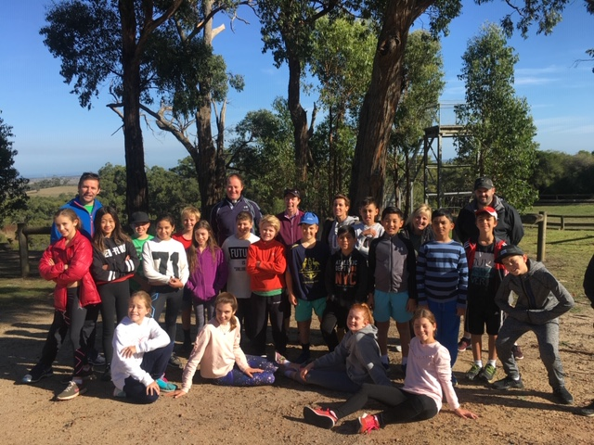**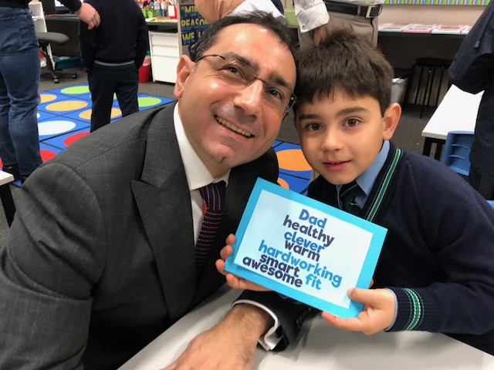

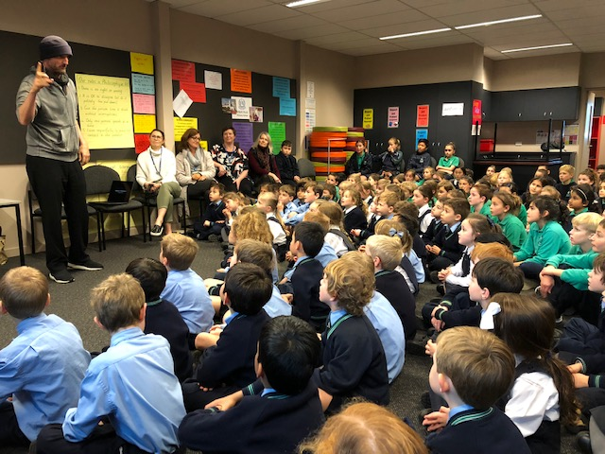Student Wellbeing

## Goal

To co-create a learning environment that promotes the importance of social and emotional learning in our Catholic context.

**Intended Outcome**

That student resilience be enhanced.

## Achievements

**The school celebrated the following successes in 2018 in Student Wellbeing:**

* We built the capacity of leaders and staff to understand, utilise and integrate the core competencies of Social Emotional Learning into the school’s curriculum and pedagogical practices.
* During Student Representative Council Meetings led by the Wellbeing Leader students created a roster for the Buddy Bench to support students in the playground.
* Termly values assemblies continued to be a highlight enabling student leaders to share the focus of the value for the term.
* The language of Restorative Practices continued to be embedded in our conversations with students, between students and within our community and we continued with weekly whole school meditation sessions followed by Circle Time on Mindful Mondays.
* The school deepened our connection with Catholic Care through the support of a provisional psychologist providing support for the social and emotional wellbeing of students and parents at St Roch’s on a weekly basis.
* The Wellbeing Leader led the Michael Grose Leadership Program for Year 5s to prepare them for the Leadership roles in Year 6.
* The Drumbeat Program was provided for the Year 6 students through connections made with the City of Stonnington Council to enhance the students’ resilience and leadership skills
* Year 6 students attended the Grip Leadership Conference to enhance their leadership skills
* Lunchtime clubs such as Chess Club continued to provide students with a quiet alternative to active playtimes.
* Additional classroom support was made available with the provision of extra hours for Learning Support Officers in all year levels.
* Small focus groups used in all classes, targeting the range of specific and individual learning needs of students.
* Modification of curriculum to meet the needs of students with special needs.
* Regular Wellbeing Team meetings (Principal, Wellbeing Leader and Learning Diversity Leader) to discuss students’ needs.
* Professional Development for Staff in the area of Special Needs, for example, Trauma, Personalised Learning Plan writing and SMART goals
* Staff completed the Disability modules to broaden their knowledge in this area
* Staff completed Mandatory Reporting module in accordance with Child Safety procedures

|  |
| --- |
| VALUE ADDED |
| * Michael Gracey, Director of The Greatest Showman spoke to the whole school about Resilience and Persistence * External Consultant Kristy Elliot modelled Restorative Practice and Circles in classrooms and led Professional Learning Team Meeting for staff * Perceptual Motor Program for Prep to Year 2 students * Students wore a touch of red to acknowledge the Day for Daniel providing a platform for a focus on safety. * Prep 2019 Information Night for parents and 2 transition sessions offered for the students together * Australian Childhood Trauma Group working with staff and students at St Roch’s * Year 6 students participated in 6 week City of Stonnington ‘Step-Up Transition Program’ * Buddy Reading Program where older children read to younger children in the Library * Year 3-6 Christmas Choir sang for aged care residents at Cabrini and Mecware |

|  |
| --- |
| STUDENT SATISFACTION |
| Insight SRC Annual Survey Data- Student Surveys – The following questions and scores derived from the Student, Parent and Staff surveys relate to community perception of student wellbeing.  **Students: Scores are on a scale of 1-5, with 1 being the lowest score and 5 the highest score.**   * I feel good about being a student at this school – 4.4 * My teachers are good at helping students with problems – 4.1 * My teachers really want to help me to learn – 4.6 * My teachers help me to do my best – 4.4   C:\Users\office\AppData\Local\Microsoft\Windows\INetCache\Content.Outlook\HU1E7F2I\IMG_6975.jpg**Staff: Scores are on a scale of 1-5, with 1 being the lowest score and 5 the highest score.**   * Staff in this school strongly believe they can make a difference to the wellbeing of students – 4.6 * Staff in this school strongly believe they can make a difference to the student’s learning – 4.8 * Staff in this school understand the importance of partnering with parents to help students achieve their full potential – 4.4 * Staff in this school always focus on improving the quality of the school’s teaching and learning practices – 4.6   **Parents: Scores are on a scale of 1-7, with 1 being the lowest and 7 the highest score**   * My child looks forward to the learning they do at school – 5.8 * My child looks forward to going to school – 5.8 * My child is mastering a range of social skills – 5.8 * This school always aims to improve the quality of education it provides – 5.9 * The teachers at my child’s school motivate my child to want to learn – 5.9 * The teachers at my child’s school are extremely dedicated – 6.2 |

|  |
| --- |
| STUDENT ATTENDANCE |
| At St Roch’s we have strong student attendance. This is reflected in the high level of engagement which is identified in the school data. Students are encouraged to arrive at school at 8:30am so they can engage and play with friends. The bell sounds at 8:50am and the day begins with a whole school greeting from the Principal. Any student who misses this 8:50am start time is required to be signed in by their parent/carer at the Front Office, where an Office Manager, Learning Support Officer or Leadership Team member escorts the child to their classroom. This tight process ensures we minimise disruptions to class learning time. Attendance reports are printed at 9.15am and in the event a child is marked as absent with no explanation, a call is promptly made to the parent or emergency contact to confirm the child’s absence.    Attendance Reports are printed daily and are collated and checked by the Principal and Wellbeing Team, who look for patterns of non-attendance. Should concerns arise, the parents are contacted and invited to meet with the classroom teacher and the Principal to resolve the underlying issue. Note: The School Attendance Guidelines apply to all registered schools in Victoria and outline procedures for schools to record, monitor and follow up student attendance in order to meet the requirements of the relevant act and regulations. |

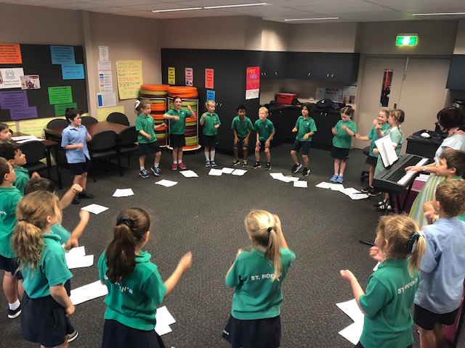Child Safe Standards

## Goal and Intended Outcome

## St Roch’s Parish Primary School strives to form quality partnerships with school families to support the academic, physical, social and emotional and spiritual learning of all students in a safe and secure environment both in and outside of the school grounds.

## Achievements

St Roch’s holds the care, safety and wellbeing of children and young people as a central and fundamental responsibility of our school. Our commitment is drawn from an inherent belief in the teaching and mission of the Gospel.

Over the past 12 months St Roch’s has furthered its commitment to providing a safe environment for all students by actively implementing processes that establish expectations and accountabilities for people working with our students. The continued application of student wellbeing programs such as Kids Matter, Restorative Practice and Circle Time have encouraged students to engage in conversations about their welfare and safety. These Child Safety initiatives have formed the foundation for our student ‘Code of Cooperation’.

St Roch’s has continued to broaden its comprehensive suite of Child Safety policies and procedural documents to incorporate aspects relating to the following:

* Working With Children Check Requirements – To reflect changes to the WWCC that came into effect in August 2017;
* Organisational Duty of Care –Defining the school’s statutory ‘duty of care’ to take all ‘reasonable precautions’ to protect students and young people under their care;
* Reportable Conduct Scheme – Outlining how the school responds to allegations of child abuse and child-related misconduct by employees and volunteers;
* School Attendance Guidelines – Defining the school process for monitoring student attendance and strategies to be implemented where their safety or welfare is of concern.

**Staff Training and awareness raising strategies**

All St Roch’s staff members participate in regular briefings and training to ensure the school’s legislative obligations and the school’s Child Safety Strategy remains front of mind. Staff members have participated in a variety of training initiatives including:

* On-line Mandatory Reporting Modules (Annually);
* Protect – Responding to Suspected Student Sexual Offending;
* The School’s Child Safety Policy & Code of Conduct (Annually);
* Reportable Conduct Scheme Requirements;
* Organisational Duty of Care;
* Risk Management – Excursions & Camps;
* School Attendance Requirements.

**Consultation with the Community**

St Roch’s has continued to actively engage the school community in all aspects of Child Safety. Briefing sessions have been held with members of the school community to further disseminate requirements of Child Safety Standards, the school’s Code of Conduct and its expectations of those who intend to participate in ‘Child Connected Work’.

The school’s Child Safety Strategy is communicated to new members of the school community at enrolment, with ongoing briefings facilitated via the school newsletter and website.

A review of all Child Safety Standard documents took place in consultation with the School Board to ensure that they remain relevant.

**Human Resources Practices**

St Roch’s continues to implement Human Administrative and Human Resource practices to ensure its recruitment and performance management processes not only identify the most suitable candidates to undertake ‘Child Connected Work’, but fosters continual improvement in Child Safety practices. To achieve this the school ensures that the following Human Resource processes have a child safety focus:

* Position advertisements
* Position descriptions
* Referee Checks
* Key Performance Indicators
* Victorian Institute of Teaching Registration (VIT)
* Working with Children Checks & National Criminal Record Checks
* Screening of Casual Relief Teachers, Contractors, Visitors and Volunteers.

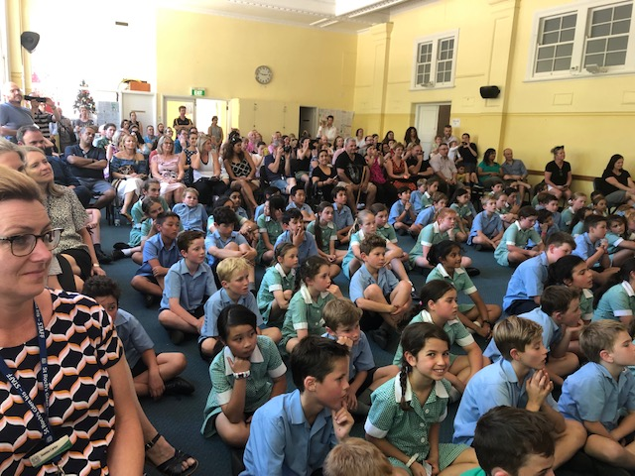St Roch’s maintains detailed records to support the screening and ongoing supervision of any individual required to undertake ‘Child Connected Work’. **Leadership & Management**

## Goal

To develop a work environment characterised by staff cohesiveness, improved professional relationships and learning with a stronger sense of ownership.

**Intended Outcome**

That staff climate will improve.

## Achievements

**The school celebrated the following successes in 2018 in the sphere of Leadership and Management:**

* The Principal meets individually with the Parish Priest weekly to share diaries, discuss and plan for events in the weeks ahead and debrief on the week that has been.
* Weekly School Improvement as well as Day to Day Management Leadership Meetings are held to maintain transparent and cohesive links, involving the Principal, Deputy Principal/Religious Education Leader/Learning Diversity Leader, the Wellbeing Leader, the Literacy Leader and the Mathematics Leader.
* Anonda LaMessurier was employed in a coaching capacity to support each member of the Leadership Team. Anonda met with each member of the Leadership Team termly as well as the team meets with the Catholic Education Melbourne Team on a termly basis. At these meetings we share What is Working Well (WWW), Even Better If (EBI) and set goals for the following term which is another effective way that we keep on track with our four year School Improvement Plan.
* Agendas and minutes for staff meetings are recorded electronically on the school’s Google Drive for staff to access.
* ‘Ways of Working’ are reviewed regularly to ensure staff collaboration and professional working relationships.
* Leaders attended Catholic Education Melbourne Eastern Region network and cluster meetings.
* Formal and Informal Annual Review Meetings are conducted for all staff.
* Policies were reviewed for ratification by the School Education Board.
* The Principal and the Staff Representative attended Parish School Board Meetings.
* The Principal and Deputy Principal attended Parents and Friends Association Meetings.
* Prep 2019 Information Evening and Orientation sessions were held for prospective Prep children.
* The staff at St Roch’s undertook continued professional learning in Emergency Management with this course outlining the emergency procedures relevant to our site. Evacuation maps are displayed on the various exits around the school and the children have been talking about safety in and around the school.
* The School Audit was conducted by Deloittes. Our school accountant James Manche and Office Manager - Finance, Tanya Bolam are to be congratulated for their thorough work.
* Throughout the year I joined some of our local Catholic Primary School Principals in voicing our concerns around the Federal Government’s Education Funding Model. We met with local Higgins Member, The Honourable Kelly O’Dwyer MP and we had a very healthy and robust discussion on what effect these current funding decisions will have on Catholic education over the next ten years.
* During the year we thanked all staff for the service and care they give so generously to the St Roch’s community and we acknowledged their years of service. At the end of 2018 we farewelled Anna Jabour who retired after 29 years of service.
* The Consultative Committee met several times to discuss structures and plans for 2019.
* School Improvement Surveys were conducted by children, parents and staff
* Year 5 students offered the Michael Grose Leadership Program facilitated by Angie Mastoras – the student submitted a letter to the Principal, attended an interview with the Principal and made a speech to Years 4-6. Voting took place by both Year 5/6 students and staff
* We completed 6 official school tours and displayed 6 St Roch’s enrolment bill boards around our community. Enrolment interviews were conducted and offers made on 31 May.
* Tanya Bolam, Office Manager, studying Nursing and completing placements each term. Her studies will conclude in 6 months time.
* Marian Nicolazzo and her Literacy work at St Roch’s was published in a chapter of Understanding and Supporting Young Writers from Birth to 8.
* Donna Anderson and our work with STEM at St Roch’s and with the Collective was published in the Executive Director’s News.
* Year 6 Leaders attended the GRIP Leadership Day
* Flu Injections for staff provided by 2 local GPs

|  |  |
| --- | --- |
| EXPENDITURE AND TEACHER PARTICIPATION IN PROFESSIONAL LEARNING | |
| **DESCRIPTION OF PL UNDERTAKEN IN 2018** | |
| **Professional Learning in which staff participated included:**   * Child Safety Standards with Martin Tennant – Safesmart Solutions * Child Safety – Online Mandatory Reporting Modules * Child Safety – Emergency Management and Warden Training with Dynamiq * Child Safety – First Aid Level 2 and anaphylaxis refresher * Religious Education – Curriculum Renewal, Planning and Assessment * Religious Education Collective * Religious Education 2 day CEM Conference for two of our leaders in Religious Education * Parish Adult Faith Nights * Spirituality Day and staff formation around faith and life – Carmelite Monastery * Integrated Inquiry / Capabilities with Donna Anderson * Learning & Teaching – Assessment and Reporting * Learning & Teaching – The Capabilities with a focus on Critical and Creative Thinking * Full day Integrated Inquiry planning sessions P-6 each term led by Donna Anderson * Science & STEM with STEM Collective including partnership with Scienceworks and National Gallery Victoria and staff visiting other schools in the Collective * Visual Arts – Preparation for St Roch’s Art Exhibition in Term 3 * English – Phonics in Context * English – Writing and Spelling - Orthography * English – Orthography with Lyn Anderson * English and Mathematics Data Analysis and Moderation * Mathematics - Mathematics Assessment Interviews (MAI) and Growth Points * Mathematics with Mick Ymer * Extension and open ended activities in Mathematics and Writing * Learning Diversity – NCCD & Personalised Learning Plan (PLP) and Adjustment writing for identified students needing additional support or extension * Learning Diversity – Disability Standards Online Modules * Learning Diversity – Australian Childhood Trauma with Gregory Nicolau * Student Wellbeing – Circles & Restorative Practices with Kristy Elliott * Student Wellbeing – Social & Emotional Learning * ICT & Digital Technology with Marty McGauran * Cybersafety with Carli McGauran and Marty McGauran * School Improvement Surveys data analysis, reflection and celebration with CEM * Leadership - Principal, Deputy Principal, Mathematics, RE, Wellbeing, Learning and Teaching, eLearning, Student Services and Literacy Leader network meetings and conferences * Leadership Team Coach – One on one coaching sessions with Anonda LaMessurier * Parent Partnerships – Involvement and Engagement with Tony Dalton * ACHPER Conference for our PE Teacher * Effective Mentoring Training Program with VIT for our Deputy Principal   We believe that professional learning supports our overall school improvement and highlights the commitment of staff to the growth of their professional knowledge, practice and wellbeing. Amongst the professional learning we made it a priority to dedicate PLT time to showing the value of time with actual time on task for analyzing data, writing reports and PLPs and we also took the opportunity to have breakfast together each term. | |
| **NUMBER OF TEACHERS WHO PARTICIPATED IN PL in 2018** | 23 |
| **AVERAGE EXPENDITURE PER TEACHER FOR PL** | $3023.00 |

|  |
| --- |
| TEACHER SATISFACTION |
| This data is taken from the annual school surveys (as administered by Insight SRC). This survey is completed by staff. The results from the Staff Surveys measuring the Organisational Climate Index and the Teaching Climate Index, indicate that St Roch’s results are well above the Australian mean with the Organisational Climate Index across all indicators moving from 78.3 in 2016 to 78.5 in 2017 to 81.2 in 2018.  Insight SRC Annual Survey Data- Student Surveys – The following questions and scores derived from the Student, Parent and Staff surveys relate to community perception of Leadership and Management.  **Students: Scores are on a scale of 1-5 with 5 being the lowest score and 5 being the highest score.**   * My teachers really want to help me learn – 4.6 * My teachers provide help and support when its needed – 4.4 * My teachers put a lot of energy into teaching our class – 4.3   **Staff: Scores are on a scale of 1-5 with 5 being the lowest score and 5 being the highest score.**   * Staff take pride in the school – 4.6 * There is support from the leaders at this school – 4.5 * I am clear about my professional responsibilities – 4.3 * Staff in this school can rely on their colleagues for support and assistance when needed – 4.6 * The staff are committed to the school’s goals and values – 4.6 * The school has a clearly stated set of objectives and goals – 4.3 * Staff in this school always try to improve the quality of their teaching – 4.6 * Teaching practice in this school engages students in their learning – 4.6 * Staff in this school are encouraged to improve their skills, knowledge and performance – 4.3   **Parents: Scores are on a scale of 1-7, with 1 being the lowest score and 7 being the highest score.**   * The teachers at my child’s school are extremely dedicated – 6.2 * The teachers at my child’s school are very passionate about teaching – 6.2 * I feel comfortable about approaching this school with any concerns I might have – 5.9 * This school always aims to improve the quality of education it provides – 6.0 |

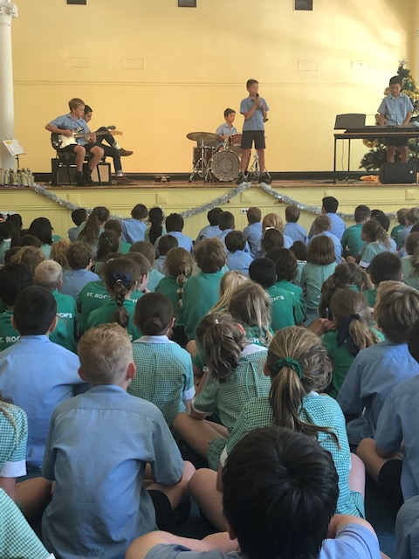School Community

## Goal

To strengthen links with the local and global community

## Intended Outcome

That students will be more engaged in a local and global community through a contemporary approach.

## Achievements

**The school celebrated the following successes in 2018 in the sphere of Student Community:**

* Senior students led fundraising campaigns and developed community awareness for a number of charities, such as Caritas, St Vincent de Paul ‘Assist a Student’ and CatholicCare’s Family Week.
* Parent Information Night for all year levels provided an opportunity for parents to hear about the vision and direction for the year from the Principal. The parents workshopped ‘what is working well’ and ‘what could be even better if’ in the area of parents being authentically engaged in their children’s learning. The parents also had the opportunity to visit their child’s class and hear from their child’s classroom teacher.
* Our Parents and Friends Committee welcomed the St Roch’s School Community at the commencement of the 2018 school year with a Morning Tea for our new and current families.
* Our social events organised by the Parents and Friends Committee started with Welcome Drinks. This followed with our Annual Bush Dance which was a lovely way to celebrate our families and round off Catholic Education Week.
* Our Mother’s Day and Special Person’s Breakfast was a wonderful celebration and our special guests were provided with some entertainment from our Prep students.
* The Fathers and Inspirational men in children’s lives enjoyed breakfast together to celebrate Father’s Day by participating in activities, photo booths and a visit to the classroom.
* The Annual St Roch’s versus St Mary’s Netball and Football games were again a wonderful example of the spirit and good will that our community prides itself on. It is such a great opportunity for our new families to be welcomed and for our past parents to return.
* The Parish Men’s Golf Day was well attended by the Dads/Uncles/Grandparents/Past Students from St Roch’s, a social activity well enjoyed by all who attended.
* Our School families and parishioners enjoyed the St Roch’s Feast Day Parish Dinner
* Our fortnightly Assemblies are celebrated on Wednesday afternoons. Our teachers now inform parents when their children are receiving awards to give them the opportunity to attend the Assembly. Our highlights Assemblies are held at the end of each term and provide us with an overview of what the students have learnt and it a great opportunity to celebrate their success.
* To engage the parent community and to support classroom helpers, a mathematical and literacy based Classroom Helpers Training Course took place to provide ways to parents to best support children when assisting in the classroom.
* Marty McGauran (STEM and Digital Technologies Consultant) led a Parent Information Evening around STEM/Digital technologies and Cyber Safety.
* The 2018 Parent Handbook was updated and shared with the community. This handbook provides all parents with information about the school’s procedures and some of its policies. This handbook can be accessed through the school website (www.srgleniris.catholic.edu.au) under the School Community link. Hard copies can be accessed from the school office.
* Michael Ymer, (Mathematics Consultant), led a Parent Workshop on how to support their child’s mathematical development at home.
* Students Prep to Year 6 participated in the Annual Twilight Sports event. This event always proves to be a wonderful opportunity for the community to gather.
* Our Prep families led Teacher Appreciation Day Morning Tea at St Roch’s. The staff enjoyed the extra special attention they received from their students and their families.
* Our Prep students enjoyed inviting their past Kindergarten teachers to join them at their special Assemblies.
* The students of Samantha’s Kindergarten visited the Prep students to enjoy some time with them in the Prep room.
* Parent Workshops conducted mid-November across two sessions focusing on celebrating achievements for 2018, sharing of School Improvement Data, Vision for 2019 and canvassing what worked well and what could be even better.
* The St Roch’s School Choir performed Christmas Carols at Cabrini Aged Care and Mecaware Aged Care Home as well as performing at special occasions such as ANZAC Day and Remembrance Day.
* Students from De LaSalle, Sacre Coeur and St Kevin’s College completed community service on our site.
* Our families attend at least one Working Bee across the year to help maintain buildings and grounds. The pride taken in keeping our school looking its best has been exceptional.
* The Leukaemia Foundation’s Greatest Shave was held at St Roch’s and raised over $10,000
* Grandparent’s Day was held on the Feast of St Joachim and St Anne with over 200 grandparents and special people in attendance.
* Major St Roch’s Parents and Friends Fundraiser was held at the Malvern Town Hall with a Casino Royale theme.
* The bi-annual St Roch’s Art Exhibition for families, parishioners and the local community was held in September.
* A team of parents and the Principal worked with the City of Stonnington in regards to updating road safety signs around the school
* James W Sadler Architects worked on the St Roch’s Master Plan with staff, students and parents
* Parent involvement includes:
  + The Parish School Board
  + 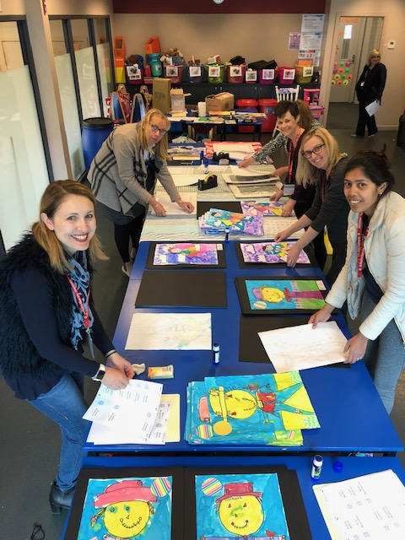The Parents and Friends Association
  + Parent class representatives on the Parents and Friends Committee
  + Parent representatives from each class organised celebrations for class events
  + Operation of the School Uniform Shop
  + Existing parents buddy up with new families to welcome them to our community
  + Classroom Helpers Program
  + Attendance at school Masses and fortnightly assemblies
  + Supervising at excursions
  + Participating at Working Bees
  + Attending and assisting at Year 4/5/6 sport and other inter-school sporting events
  + Attending sacramental celebrations and family nights
  + Parent organisation of morning teas.

Parent Satisfaction

This data is taken from the annual parent surveys (as administered by Insight SRC.) The results from the Parent SRC surveys indicate that the Community Engagement Index, which aggregates the results from all indicators on the survey has grown from 73.6 in 2016, to 75.7 in 2018, which is above the Australian mean.

**Parents: Scores are on a scale of 1-7, with 1 being the lowest and 7 the highest score.**

**Parent Partnerships**

* The staff at this school collaborate effectively with parents to optimise the learning of students – 5.5
* The staff at this school know how to engage parents in the learning process – 5.3
* The staff at this communicate effectively with parents – 5.3
* The staff at this school understand the importance of partnering with parents to help students achieve their full potential – 5.7

**Parent Input**

* The school encourages parents to have a say in planning for the future – 5.5
* I have the opportunity to get involved in planning and deciding things at this school if I want to – 5.3

**School Improvement / Learning Focus**

* The school always aims to improve the quality of the education it provides – 5.9
* The school always tries to improve – 6.0
* The academic standards at this school provide adequate challenge for my child – 5.8

**Approachability**

* There is good way communication between the school and parents at my child’s school – 5.4
* I feel comfortable about approaching this school with any concerns I might have – 5.9
* This school takes parent concerns seriously – 5.8

Future Directions

St Roch’s Parish Primary School community looks forward to further success in 2019 and beyond.

The key opportunities for improvement in the coming period would include:

* Strengthening the Catholicity and culture of the school through building staff capacity theologically, spiritually and pedagogically.
* Maintain a focus on continual improvement and a culture that promotes learning for teachers and students alike. Ensuring that understandings about contemporary learning are clarified, documented and then translated consistently into everyday practices in all classrooms and learning environments across the school.
* Building teacher capacity in Social Emotional Learning (SEL) so that staff are better able to support and educate students to be co-creators of the learning environment and to be more self-directing and resilient.
* Building strong leadership capacity, with a focus on supportive that contributes to the development of a contemporary vision and clarity of direction and purpose through enhanced staff learning and active engagement.
* Adding an additional classroom (third class added in the last 5 years) and applying for a building grant to add two classrooms, a larger administration area and an overall increase of general amenities.
* Creating and sustaining a performance and development culture which ensures that all staff are challenged and supported through individual feedback and appraisal, structured observation of each other’s classes and deep professional dialogue.

**Richard Jacques**

**Principal**

